**Stock Price Prediction with LSTM**

# **Step of full machine learning Projects:**

1. Data Collection
2. Data Modelling
   1. Problem Definition: Stock Price Prediction like Apple
   2. Data: Numerical Time Series data
   3. Evaluation: Measurement Training and Loss accuracy
   4. Features: Open, Low, High, Adj Close, Volumes
   5. Modelling: LSTM Algorithm
   6. Experiments:
3. Deployment: Web interface can be developed

# Introduction:

Long Short Term Memory Networks are referred to as LSTMs. This kind of recurrent neural network is often used in machine learning for regression and time series forecasting. LSTM neural networks are distinct from other neural networks by their ability to retain information over extended periods of time. This post will teach you how to use LSTM to forecast stock prices. I'll guide you through the process of using LSTM to forecast stock prices using Python in this post.

# **Deployment Process:**

LSTM is among the most effective machine learning methods for predicting time series. Long Short-Term Memory (LSTM) recurrent neural networks are specifically engineered to retain information for an extended duration. Consequently, an LSTM neural network can be employed whenever a neural network fails to retain information while solving a problem. More information regarding LSTMs is available here.

I will now walk you through the process of predicting stock prices with LSTM and the Python programming language in this section. Commence this endeavor by importing the requisite Python libraries and gathering the most recent stock price data pertaining to Apple Inc.

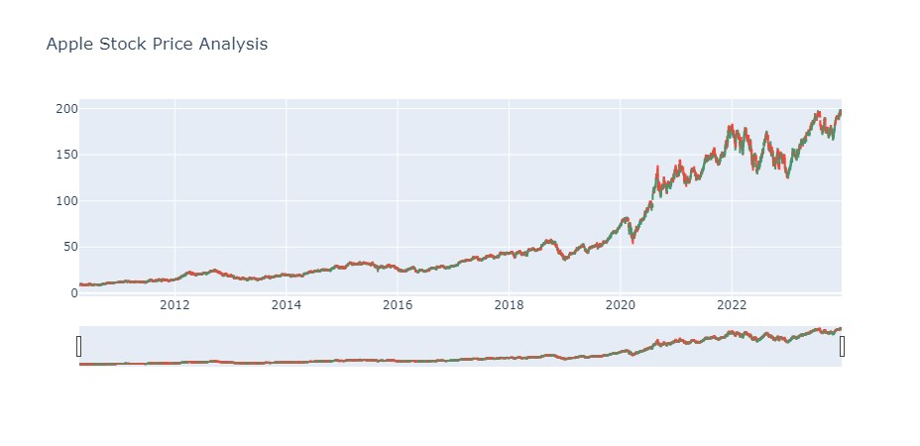

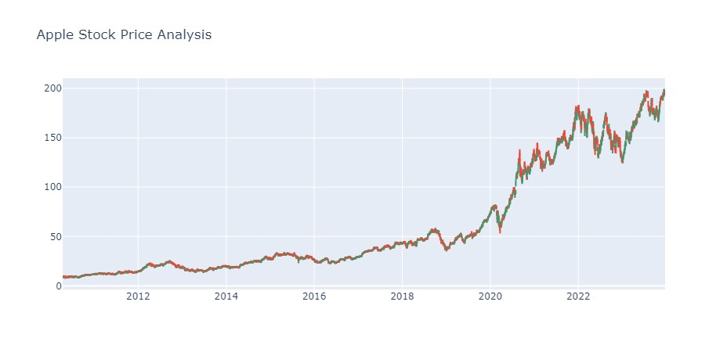

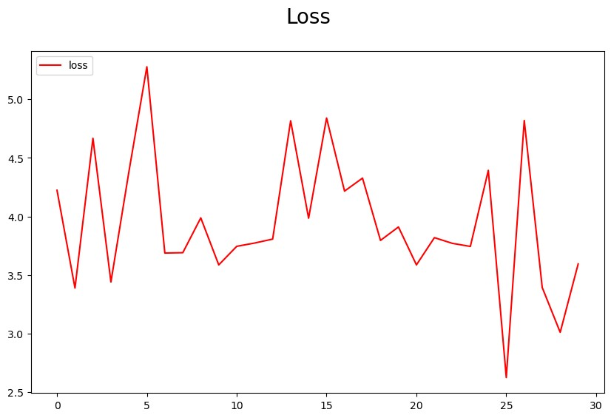

# **Summary:**

In brief, LSTM is an abbreviation for long short term memory networks. It is an extended-memory neural network that utilizes recurrent operations. LSTM is among the most effective machine learning methods for predicting time series. I hope you enjoyed this article on using Python and LSTM to forecast stock prices. Kindly inquire about anything of value in the remarks section that follows.